EMFAC Input file generator

User handbook

******************************************************************************

Version: 1.0

Python version: 3.9

Package versions:

Pandas:1.1.4

Tkinter:0.3.1

******************************************************************************

FILES YOU NEED:

1) An Excel file with monthly TEMP and RH data.

An excel worksheet with name: “All” should contain all the information needed.

Make use of the attached excel file and amend data at the “HKO” worksheet. Data in “all” should update accordingly.

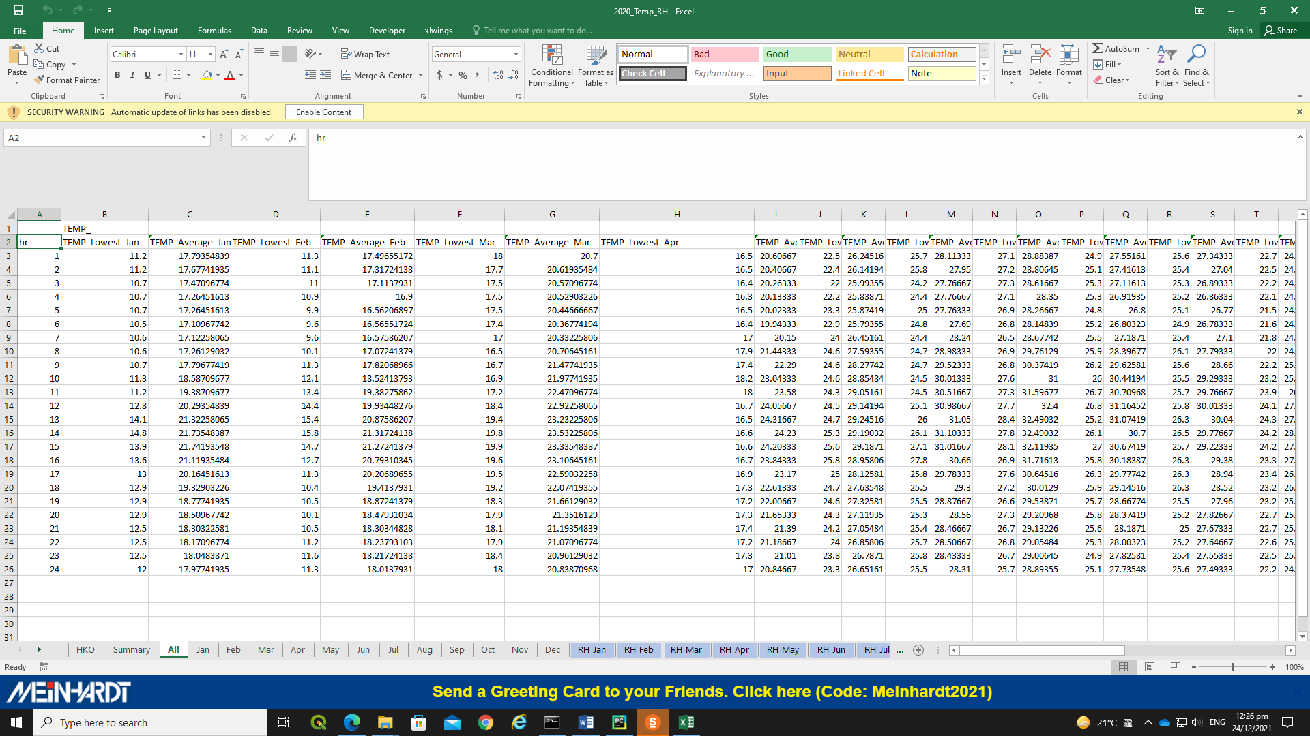

2) An .inp file as Template to generate the input files.

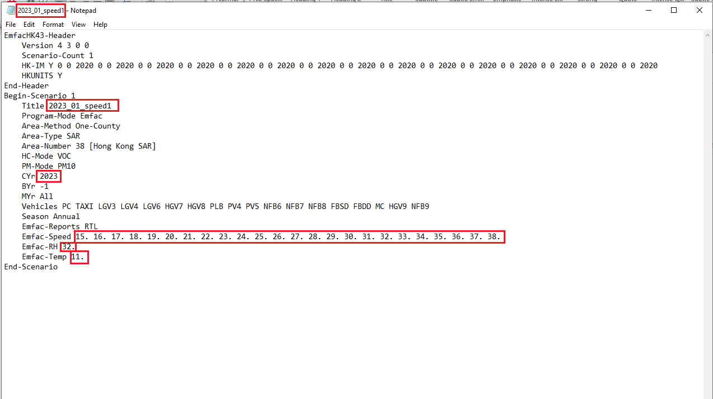

Make sure the template .inp file is correct as the input files generated will be duplicates of this template .inp file EXCEPT for the red framed parts.

******************************************************************************

GENERATE FILES

1) Open the script “main.exe”

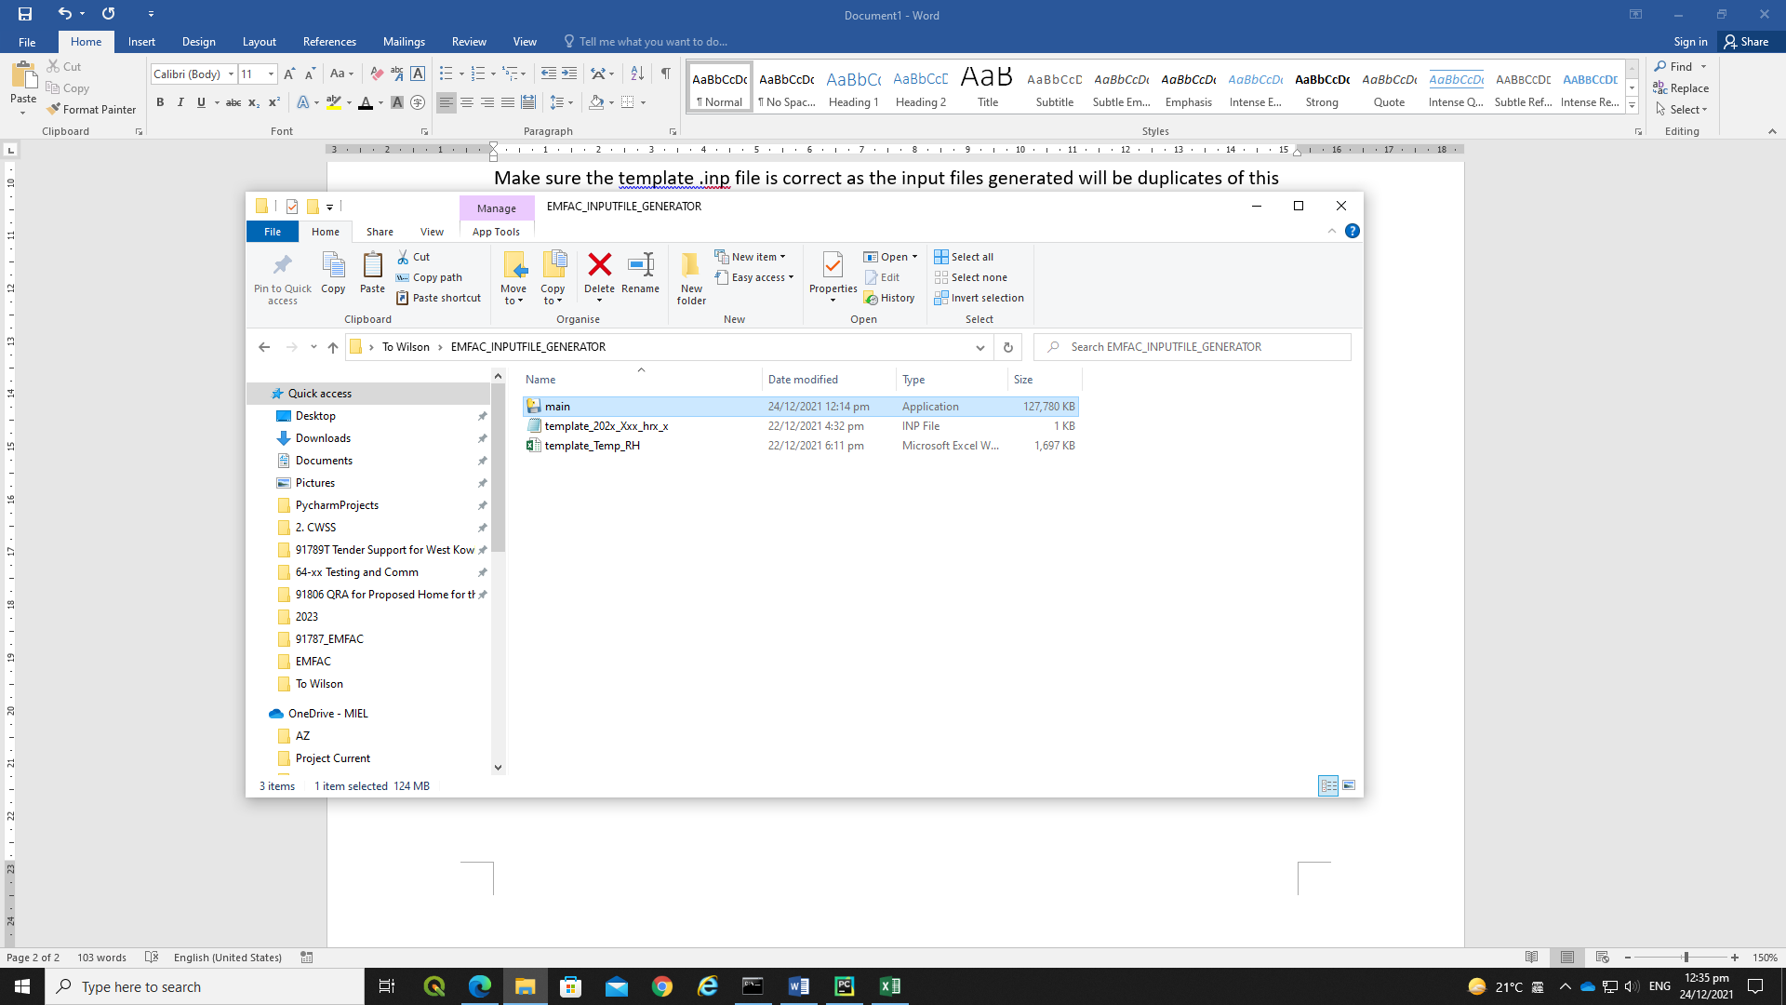

A window will pop up after a short delay.

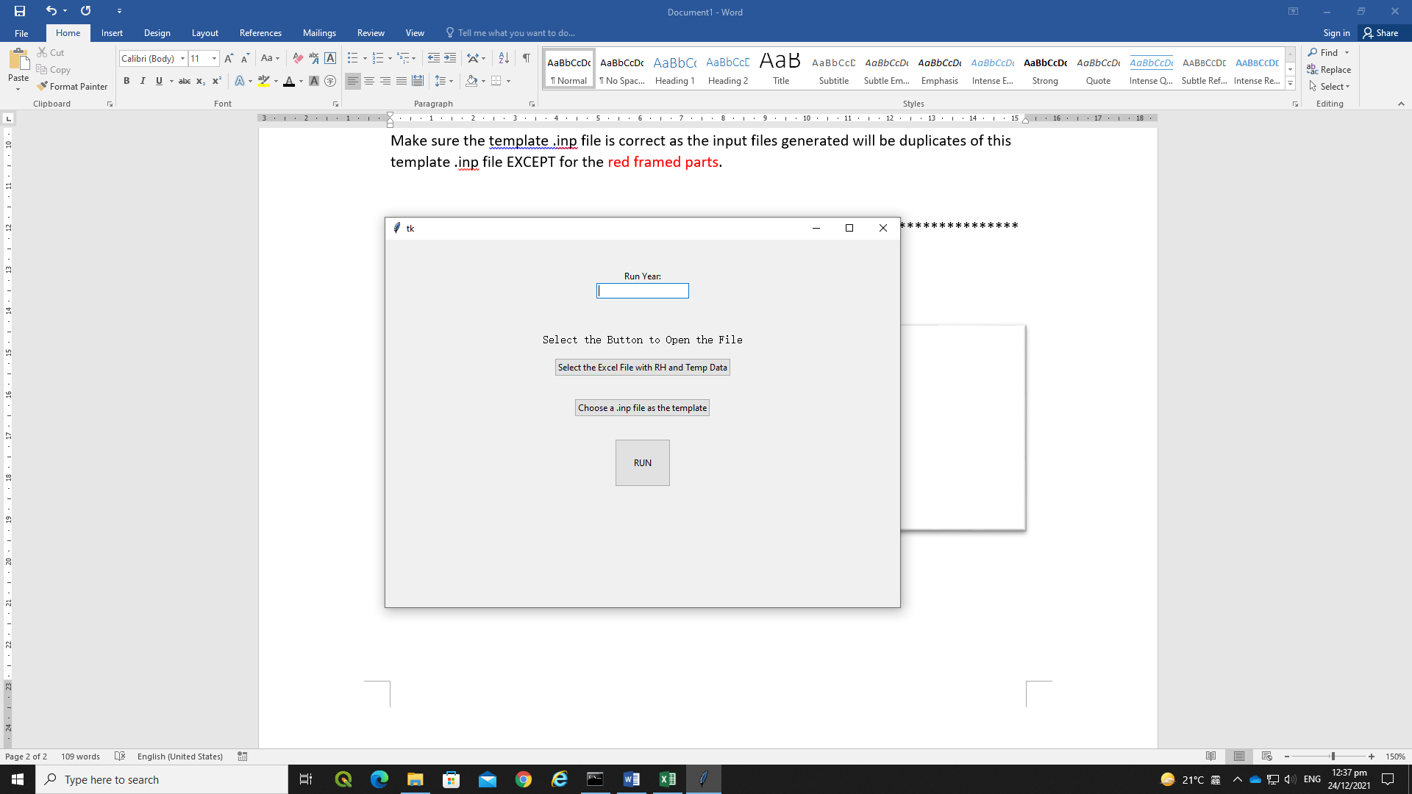

2) Enter the Year for running model.

Entry only accepts an integer with max length of 4 digit in YYYY format. (e.g: 2020)

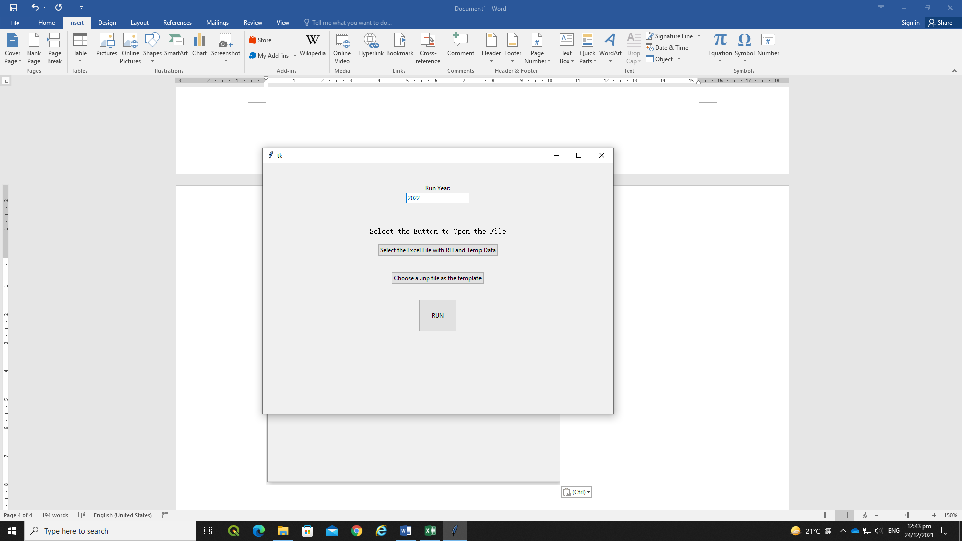

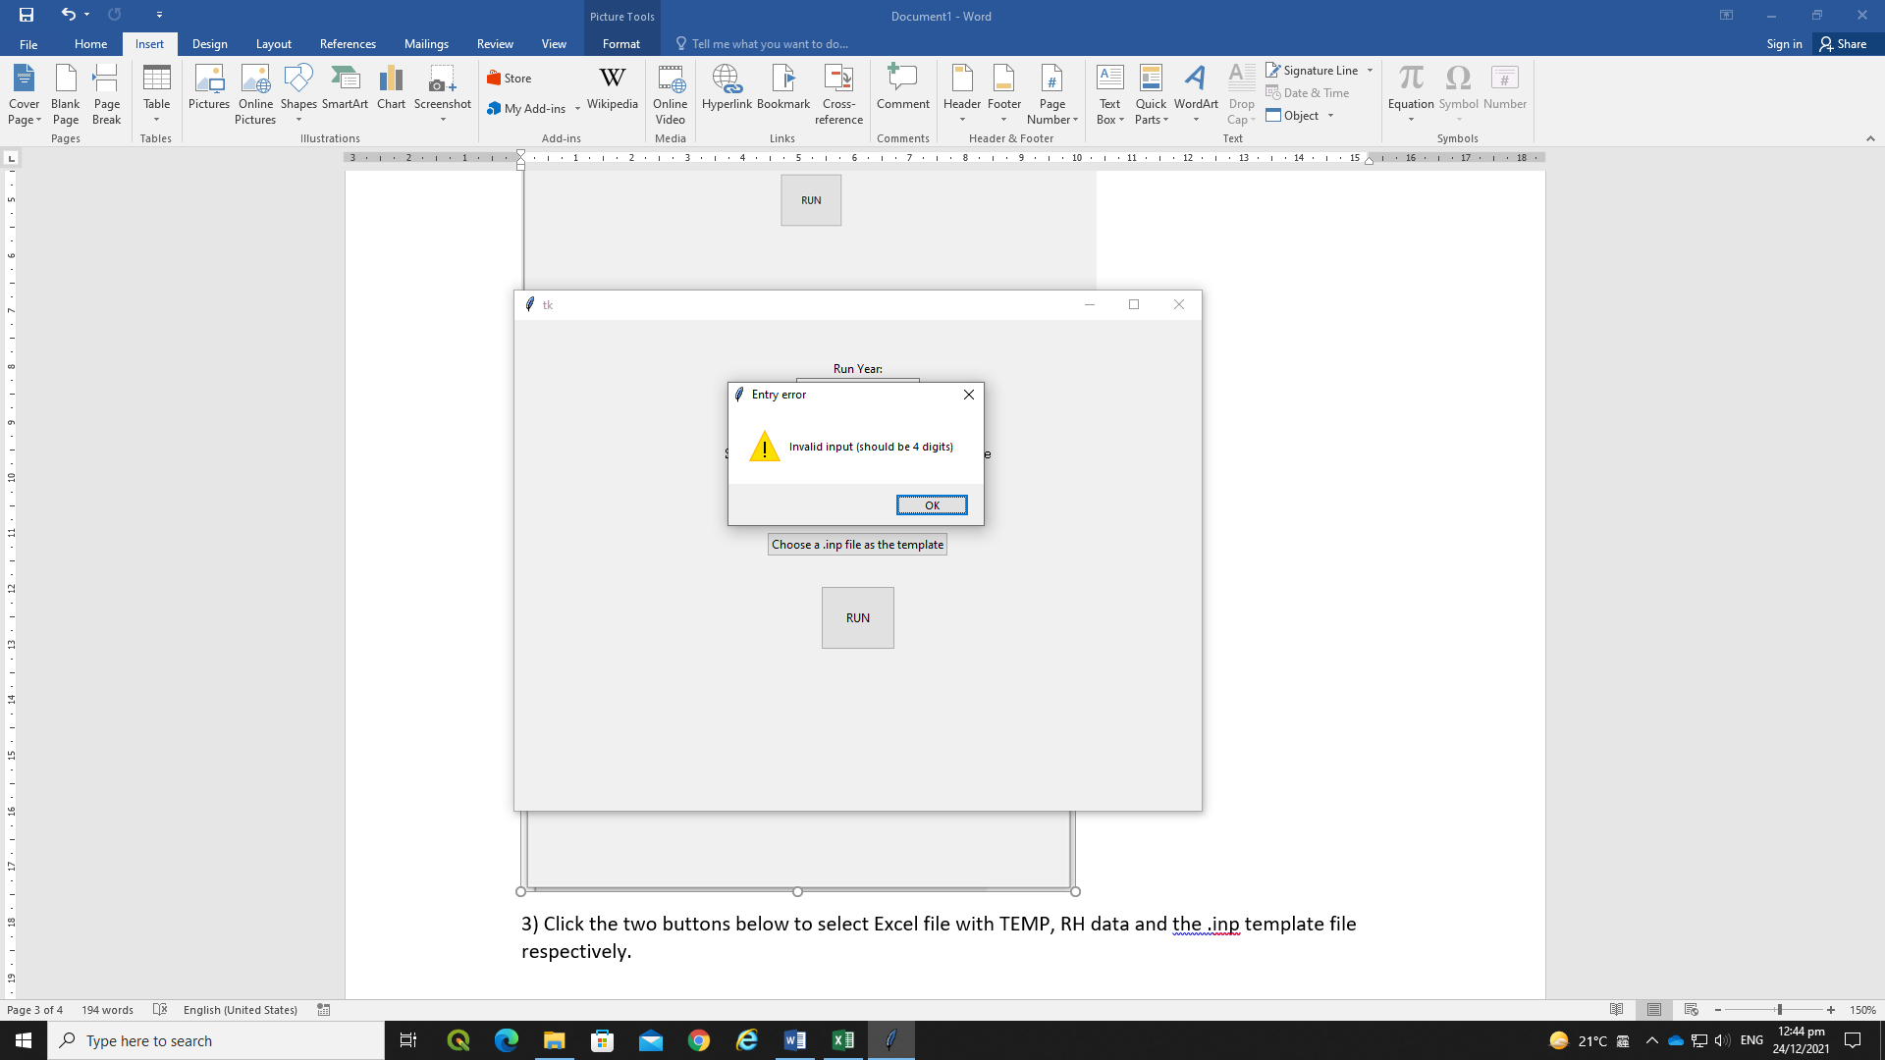

Entry error will appear if anything else is inputted.

3) Click the two buttons below to select Excel file with TEMP, RH data and the .inp template file respectively.



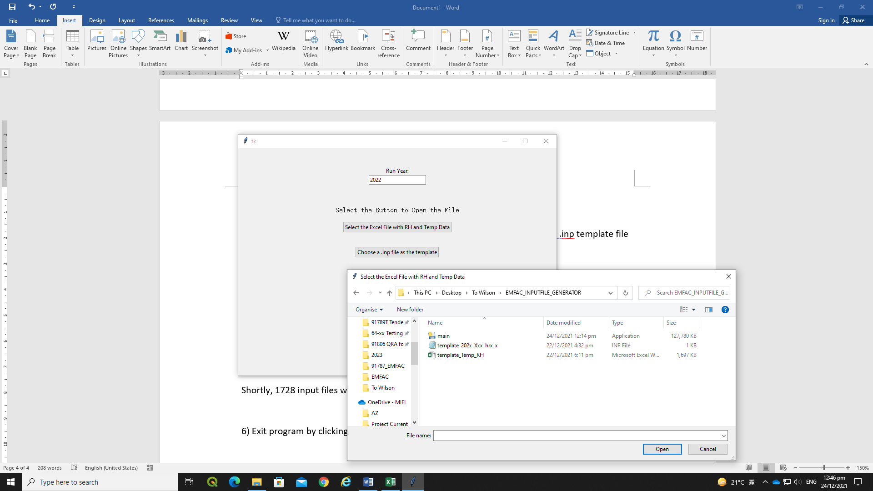

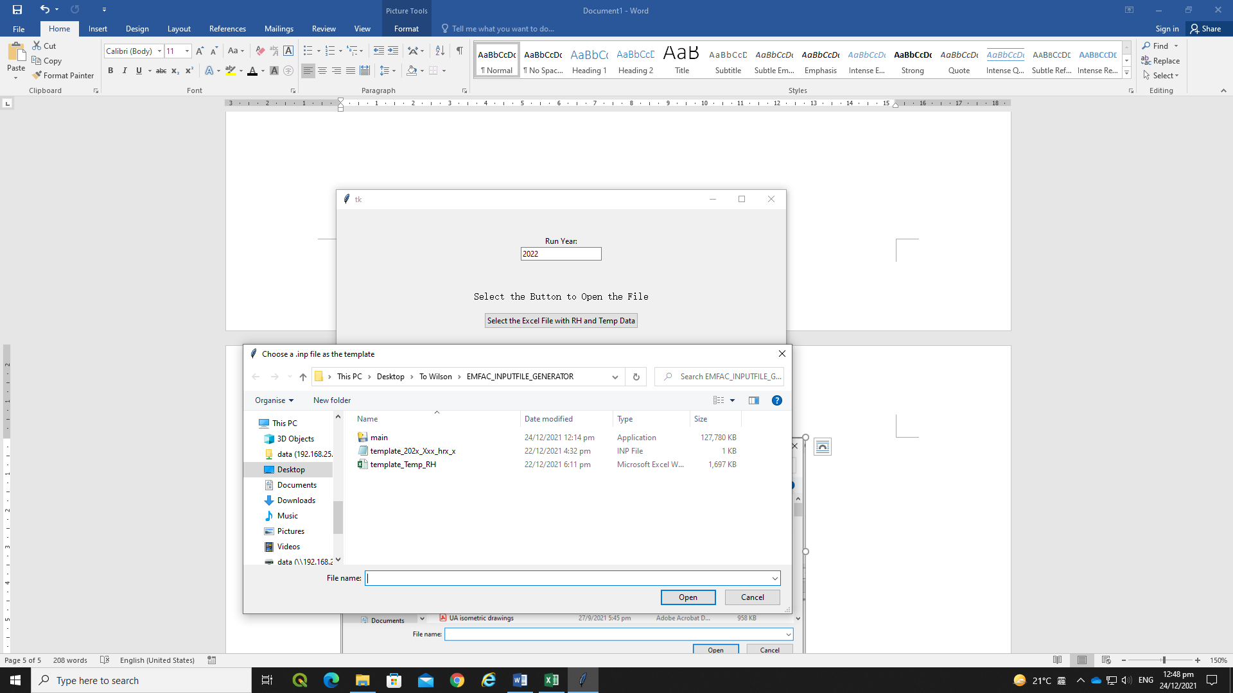

4) Filename of inputted file will be displayed.

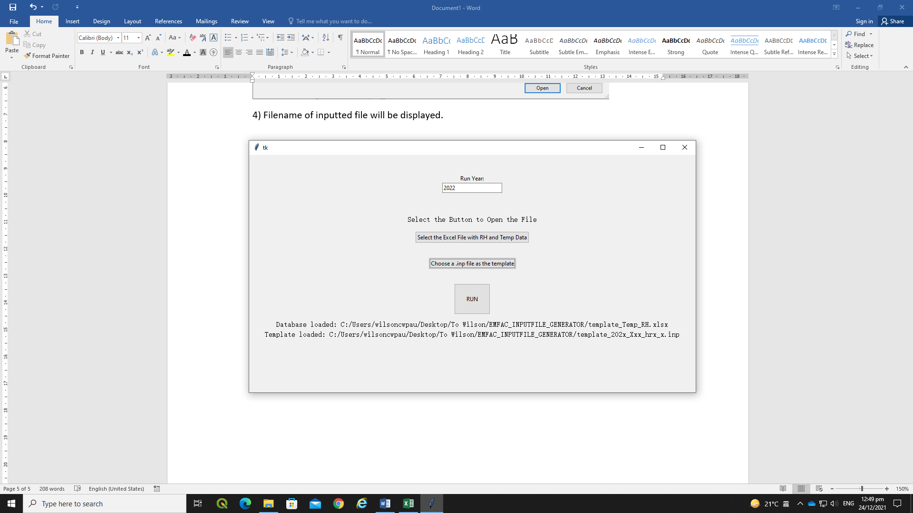

5) Click the “RUN” Button.



Shortly, 1728 input files will be produced, indicating the end of script.

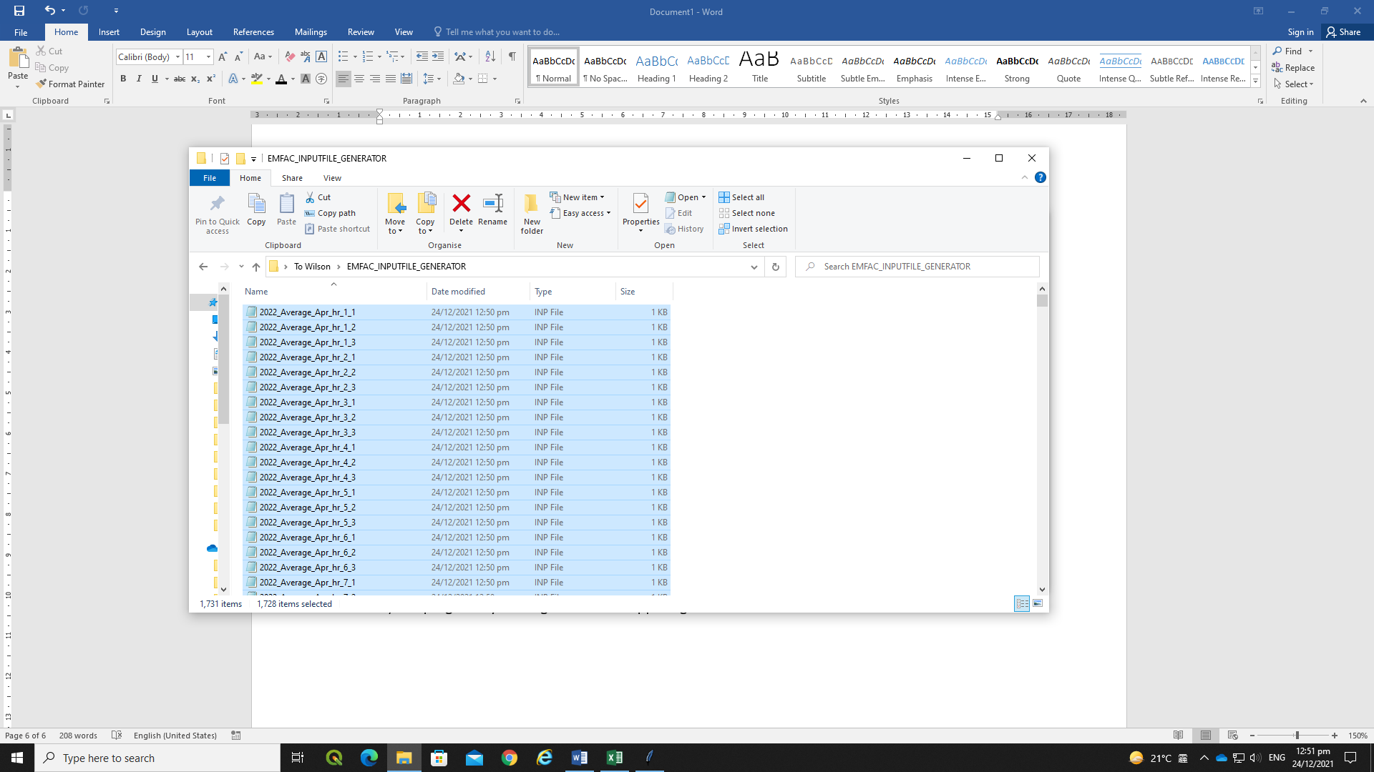

Filename is generated in the following logic:

{YYYY(year)}_{Lowest/Average}_{MMM(Month)}_hr_{H(hour)}_{N(speed:1-3)}.inp

6) Exit program by clicking the cross at upper right corner of the window.

